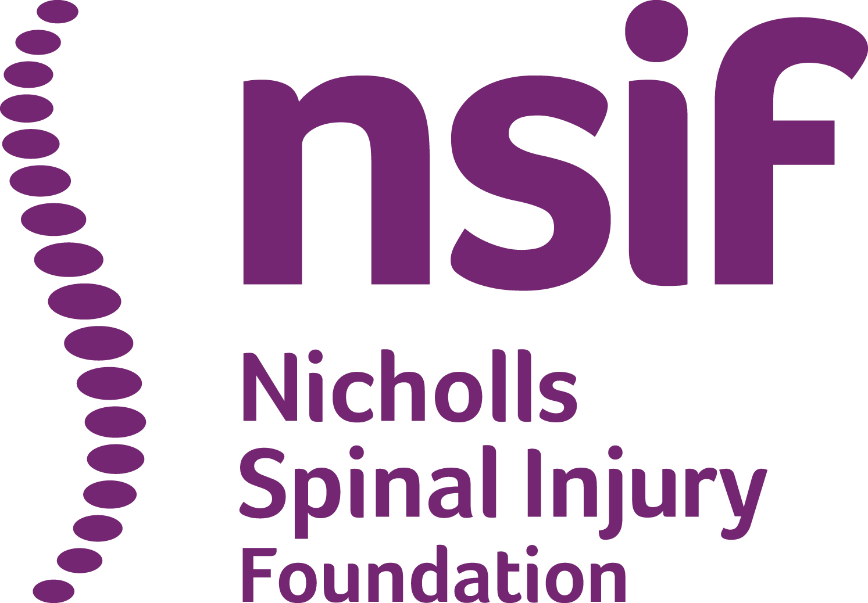
GIFT AID DECLARATION
Boost your donation by 25p of Gift Aid for every £1 you donate
Gift Aid is reclaimed by nsif from the tax you pay for the current tax year. Your address is needed to identify you as a current UK taxpayer.

Please complete and return to:

The Nicholls Spinal Injury Foundation, 27 Old Gloucester Street, London, WC1N 3AX
Charlotte@nsif.org.uk

In order to Gift Aid your donation you must tick the box below:
I want to Gift Aid my donation of £___________________ and any donations I make in the future or have made in the past 4 years to nsif

I am a UK taxpayer and understand that if I pay less Income Tax and/or Capital Gains Tax than the amount of Gift Aid claimed on all my donations in that tax year it is my responsibility to pay any difference.
My Details
Title _____________ First name (s) __________________________________________
Surname ________________________________________________________________
Full home address_________________________________________________________ ________________________________________________________________________
Post code_________________________ Date__________________________________

Signature _____________________________________
Please notify nsif if you:
- want to cancel this declaration
- change your name or home address
- no longer pay sufficient tax on your income and/or capital gains
If you pay Income Tax at the higher or additional rate and want to receive the additional tax relief due to you, you must include all your Gift Aid donations on your Self-Assessment tax return or ask HM Revenue and Customs to adjust your tax code.

